**Assignment 8.1**

1. **Get a list of employees who receive a salary less than 100, compared**

**to their immediate employee with higher salary in the same unit**

**select * from employee where salary<100 order by salary desc;**

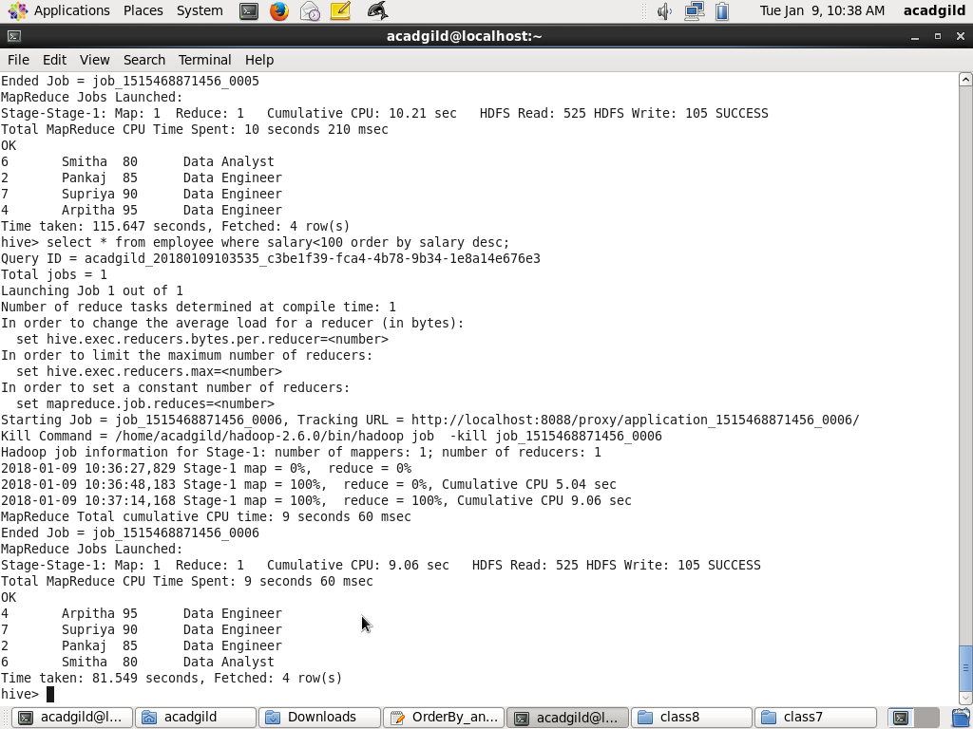

1. **List of all employees who draw higher salary than the average salary**

**of that department**

select * from (select name,dept,salary,avg(salary) over() as avgsalary from emp)s where salary>avgsalary;

